Social Media - Sample Content

The following social media posts and ideas are available to you to help spread the news about IRS-sponsored free tax preparation programs to your clients and members. The materials are catered towards Facebook and Twitter, but you are welcome to use them on other social media platforms your organization or VITA site might use.

Sample Tweets:
General Free File Promotion
- With the help of free IRS-sponsored tax prep resources like #FreeFile, you can save time and money this tax season. Find out more at www.irs.gov/freefile.

- Few things are easier than filing your taxes at no cost with IRS #FreeFile. Find out how you can save at www.irs.gov/freefile.
- #FreeFile is here to help low and moderate income families save money when filing their taxes. Learn more at www.irs.gov/freefile.
- IRS-sponsored #FreeTaxPrep resources like #FreeFile are helping qualifying taxpayers file for free and save more this tax season. We are proud to be your #TaxTimeAlly! To learn more, visit www.taxtimeallies.org.

General VITA/TCE Promotion
- Want in-person help filing your taxes? Visit a #VITA or #TCE. All are staffed by volunteers who get your taxes right! Visit www.irs.gov/vita.

- Pay a visit to your local #VITA or #TCE this tax season. IRS-certified volunteers are there to help. Visit www.irs.gov/vita to learn more!
- #VITA & #TCE sites are located at community centers, libraries, schools, shopping malls & other convenient locations across the country. To learn more about #VITA & #TCE, as well as how you can become a #TaxTimeAlly, visit www.taxtimeallies.org today!

Hashtags
- #FreeFile
- #TaxTimeAllies
- #TaxTimeAlly
- #VITA
- #TCE
- #FreeTaxPrep
- #EITC

Sample Facebook Posts:
General Free File Promotion
- Want a bigger tax refund? Check to see if you’re eligible for the Earned Income Tax Credit (EITC) and get up to $6,200 back when you file. Find out if you’re eligible to file your taxes securely for no cost using the IRS Free File program at www.irs.gov/freefile.
- File your taxes for free this season with IRS #FreeFile. Learn more about the program at www.irs.gov/freefile.
- IRS-sponsored free tax preparation resources like #FreeFile are helping qualifying taxpayers file for free and save more this tax season. We are proud to be your Tax Time Ally! To learn more, visit www.taxtimeallies.org.

General VITA/TCE Promotion
- Want in-person help getting your taxes done, but don’t know who to trust? Visit a Volunteer Income Tax Assistance (VITA) site. All sites are staffed by IRS-certified volunteers trained to get your taxes done right and to secure you the entire refund you’re owed? What’s even better? it’s completely free of charge. Visit www.irs.gov/vita to learn more!
- Volunteer Income Tax Assistance (VITA) sites present you the opportunity to receive in-person tax preparation assistance from an IRS-certified volunteer completely free of charge. AND, you can use your refund, and the money you save on tax preparation fees, to prepare for a better and more secure financial future. Learn more at www.irs.gov/vita.
- Volunteer Income Tax Assistance (VITA) and Tax Counseling for the Elderly (TCE) sites are located at community centers, libraries, schools, shopping malls and other convenient locations across the country. To learn more about VITA and TCE, as well as how you can become a Tax Time Ally, visit www.taxtimeallies.org today!

Sample Graphics:
For those individuals looking for custom content throughout the tax season take a look at our editorial calendar below:
DATE | GRAPHIC (with logo) | SOCIAL MEDIA POST
1/4 | 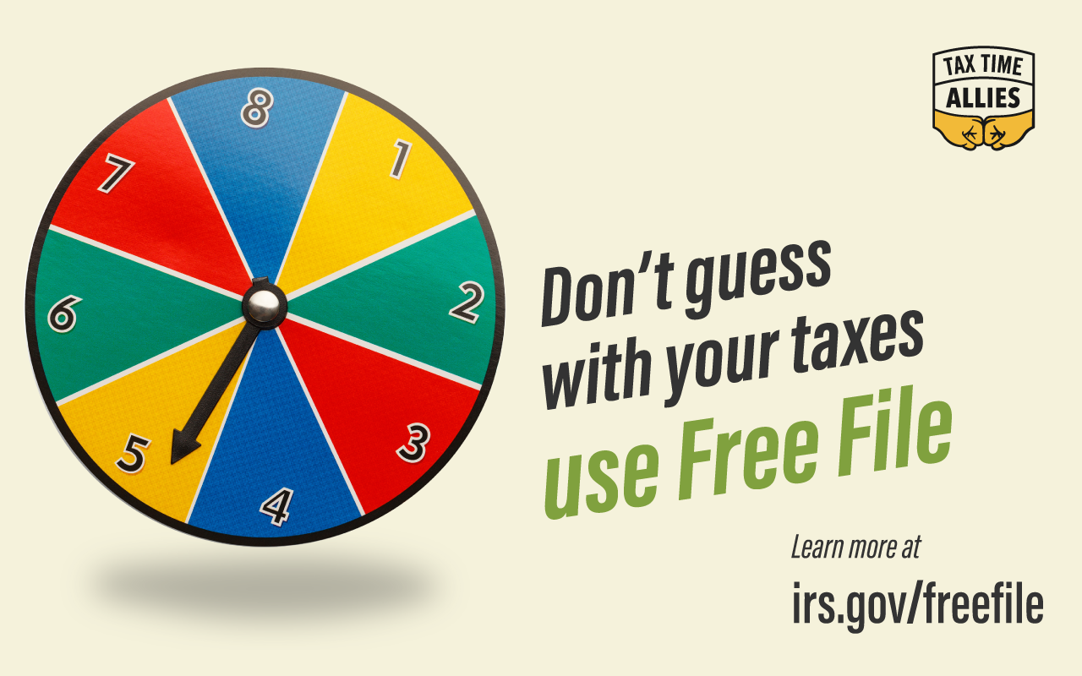 | Facebook:  - Today is National Trivia Day, so here is some trivia about free tax preparation. IRS-sponsored free tax preparation resources have helped individuals save over $1.6 billion in tax preparation fees, and have secured billions of dollars in refunds for over 50 million Americans to date. You can become one of them by using Free File or visiting a VITA site to complete your taxes. Learn more at www.irs.gov/freefile.  Twitter:  - It’s #NationalTriviaDay! Did you know that 100 Million+ Americans can file their taxes for free? Learn if you’re one at www.irs.gov/freefile.
1/7 | 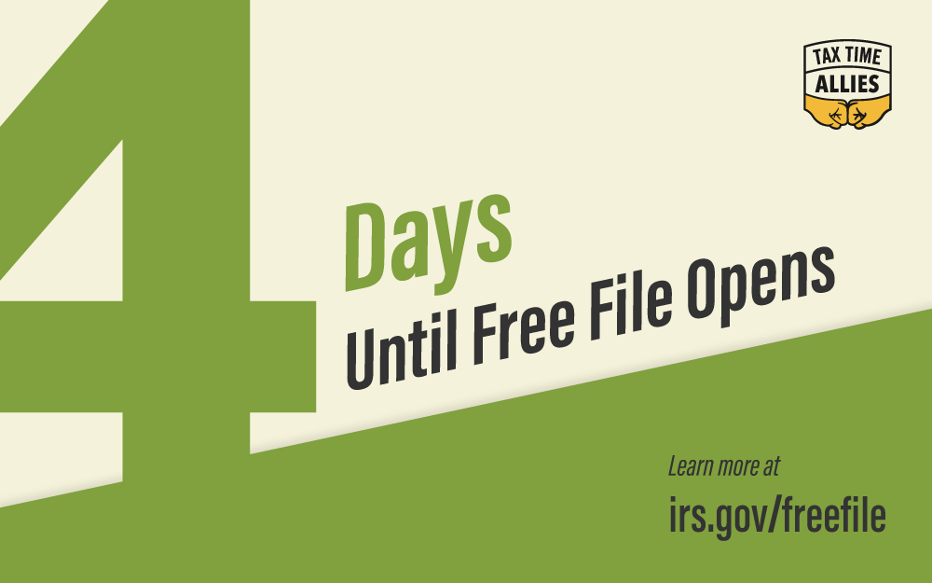 | Facebook:  - 4 days until you begin preparing your taxes for FREE with Free File. Click below to learn more! www.irs.gov/freefile.  Twitter:  - 4 days until you begin filing your taxes for FREE with #FreeFile. Visit www.irs.gov/freefile to learn more.
1/8 | 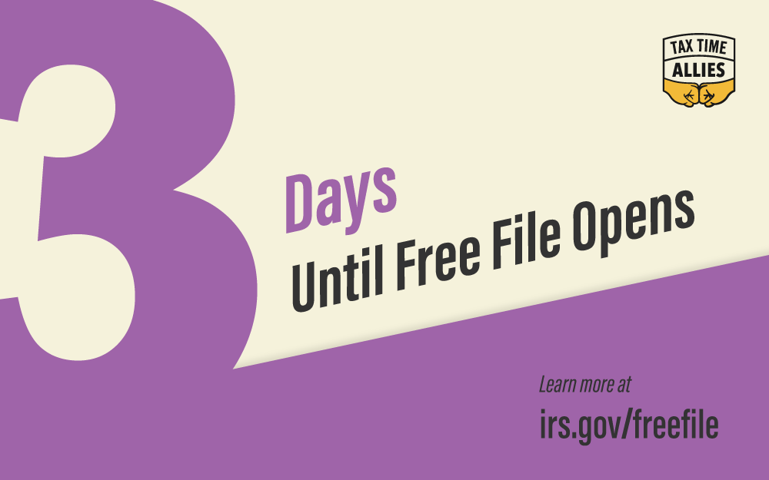 | Facebook:  - 3 days until you begin preparing your taxes for FREE with Free File. Click below to learn more! www.irs.gov/freefile.  Twitter:  - 3 days until you begin filing your taxes for FREE with #FreeFile. Visit www.irs.gov/freefile to learn more.
1/9 | 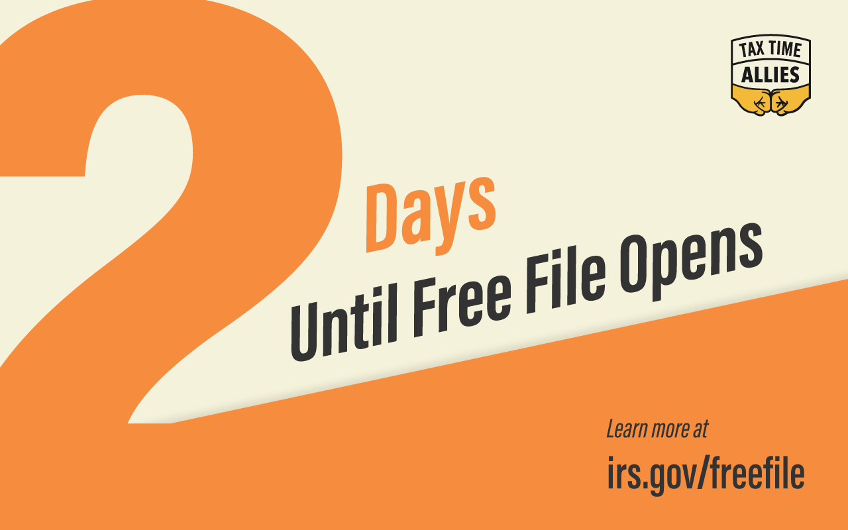 | Facebook:  - 2 days until you begin preparing your taxes for FREE with Free File. Click below to learn more! www.irs.gov/freefile.  Twitter:  - 2 days until you begin filing your taxes for FREE with #FreeFile. Visit www.irs.gov/freefile to learn more.
1/10 | 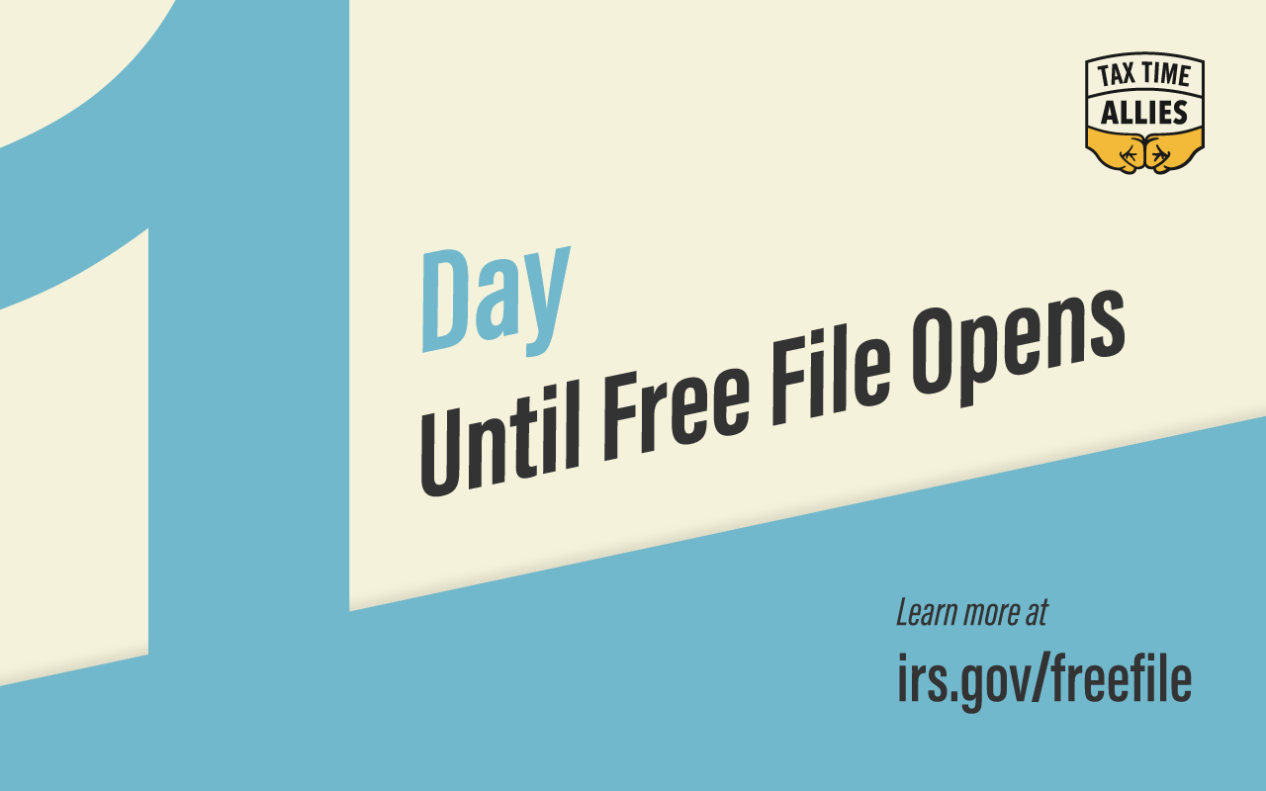 | Facebook:  - Only 1 day until you begin filing your taxes for FREE with Free File. Click below to learn more! www.irs.gov/freefile.  Twitter:  - 1 day until you begin your taxes for FREE with #FreeFile. Visit www.irs.gov/freefile to learn more.
1/11 |  | Facebook:  - Free File is officially open for business! Click below to learn more! www.irs.gov/freefile.  Twitter:  - #FreeFile is officially open for business! To learn more visit www.irs.gov/freefile.
1/25 | 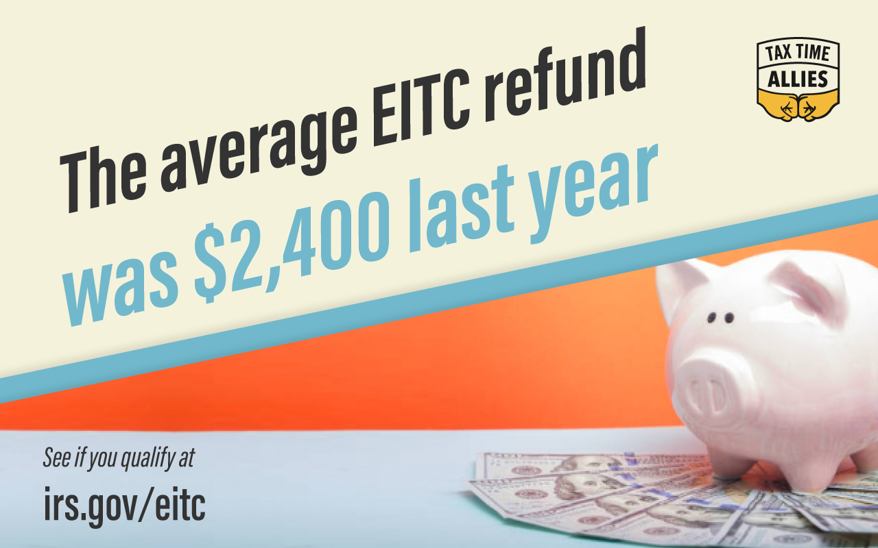 | Facebook:  - Did you know that for EITC recipients, tax refunds can be over 30% of a family’s annual income? This EITC Awareness Day, IRS Free File can help make sure that you get all the refund you’re owed. Learn more at www.irs.gov/freefile.  Twitter:  - Today is #EITCAwarenessDay! Learn more and get the most out of your tax return at www.irs.gov/freefile.  - The #EITC can make all the difference for some families. So can #FreeTaxPrep through #FreeFile. This #EITCAwarenessDay, learn more at www.irs.gov/freefile.
1/28 | 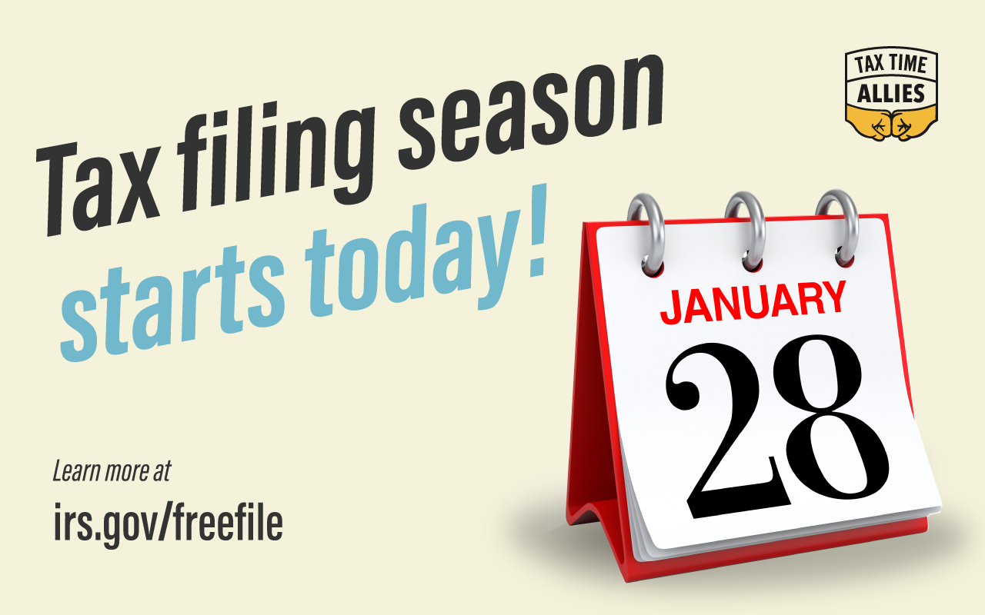 | Facebook:  - Today marks the official opening of Tax Season! Visit www.irs.gov/freefile today and find out if you’re eligible for free tax time savings.  Twitter:  - Today marks the official opening of Tax Season! Visit www.irs.gov/freefile today and find out if you’re eligible for free tax time savings.
1/28-2/1 |  | Facebook:  - It’s Tax Identity Theft Awareness Week, and we want to help make sure that you don’t fall victim to this type of fraud this tax season. By using IRS-sponsored free tax preparation resources like Free File, you’ll be able to maximize your refund, free of charge, all through the most secure platforms available. Over 70 percent of Americans qualify—check if you’re one of them here: www.irs.gov/freefile.  Twitter:  - It’s #TaxIdentityTheftAwarenessWeek! Keep your ID secure by using #FreeFile to prepare taxes. See if you qualify at www.irs.gov/freefile.
2/1 |  | Facebook:  - Today is National Freedom Day, and we’re focusing on the personal freedom that accompanies financial security. We believe that everyone deserves to be on stable financial footing, which is why we’re encouraging you to use Free File to file your taxes while pocketing the difference. Save hundreds on tax preparation and put those savings to work to set you on the path to financial freedom. Learn more at www.irs.gov/freefile.  Twitter:  - Achieve financial freedom this #FreedomDay by preparing your tax return through #FreeFile and pocketing the savings. Learn more at www.irs.gov/freefile.
2/2 | 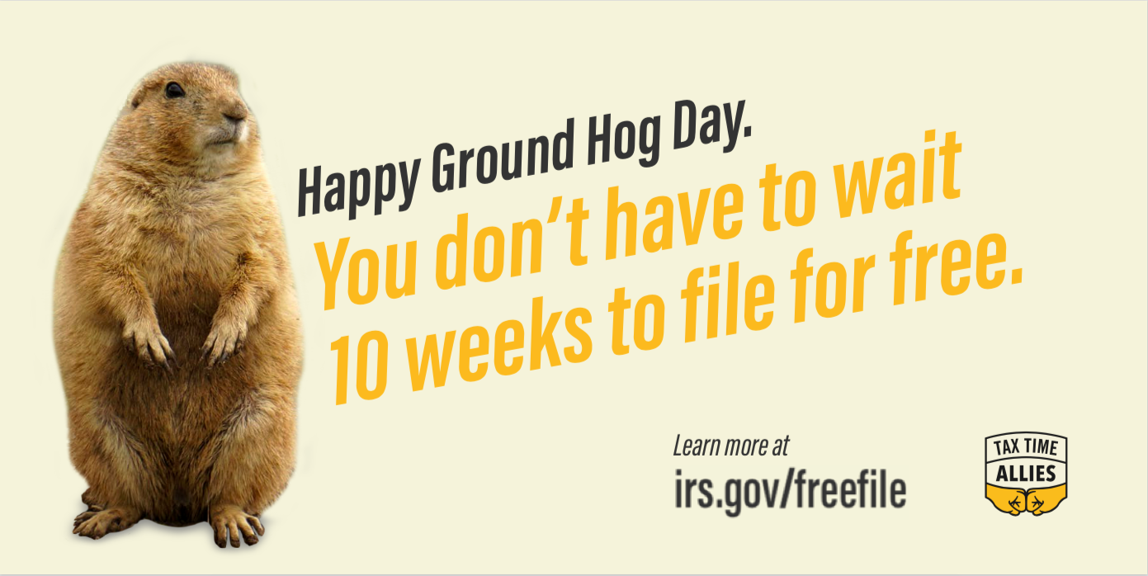 | Facebook:  - Whether the groundhog sees his shadow or not, you’ll still have to file your taxes. IRS Free File and VITA services bring decades of experience to your fingertips. Best of all, you can access both completely free of charge. See if you qualify at www.irs.gov/freefile.  Twitter:  - 6 more weeks of winter? It doesn’t matter! You can prepare your taxes using #FreeFile this #GroundhogDay. Learn more at www.irs.gov/freefile.
2/3 |  | Facebook:  - While you’re waiting for your delivery of buffalo wings for tonight’s game, why don’t you take some time and prepare your taxes through IRS Free File? 100 million Americans—almost as many as will be watching tonight—have used Free File to save hundreds on tax prep while saving the difference. Whether you’re betting on the [TEAM 1]s or the [TEAM 2] to win tonight, you can always bet on Free File as the most reliable, secure and cost-effective way to file your taxes. See if you qualify this Super Bowl Sunday by visiting www.irs.gov/freefile.  Twitter:  - Before tonight’s game, start your #FreeTaxPrep through IRS #FreeFile. See if you qualify by visiting www.irs.gov/freefile. #SuperBowlSunday.
2/14 | 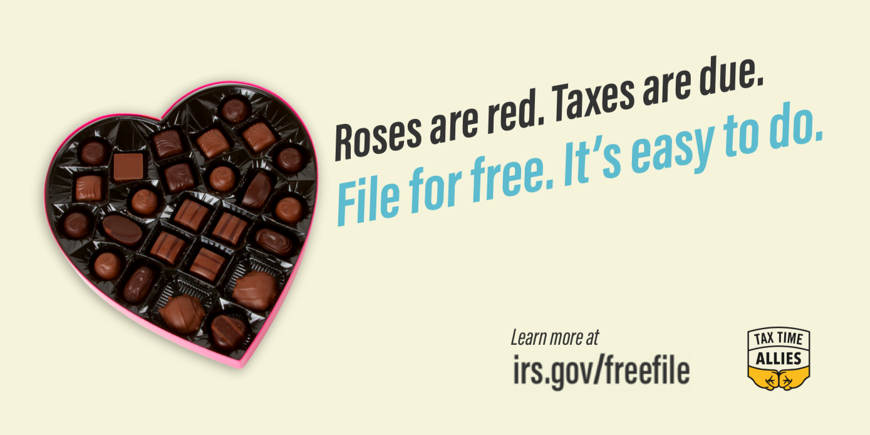 | Facebook:  - Give your wallet some love and find out if you’re eligible to file your taxes for free! [Insert State] Free File allows eligible residents to securely file their state and federal taxes at no cost. Learn more at [www.irs.gov/freefile or state specific link].  - Happy Valentine’s Day! With the help of IRS Free File, you can spread the love to your wallet. Learn more at www.irs.gov/freefile.  Twitter:  - Happy Valentine’s Day! Show your wallet a little love with IRS #FreeFile. Find out more at www.irs.gov/freefile.  - Happy Valentine’s Day! With the help of IRS #FreeFile, you can spread the love to your wallet. Learn more at www.irs.gov/freefile.
2/17 |  | Facebook:  - You can do a random act of kindness for yourself, your friends, strangers and your wallet this Random Act of Kindness Day by learning more about IRS-sponsored free tax preparation resources. Over 100 million Americans qualify to use these resources to get their taxes done right, completely free of charge. See if you qualify at www.irs.gov/freefile.  Twitter:  - On #RandomActofKindnessDay, be kind to yourself & your wallet by using IRS #FreeTaxPrep to get your taxes done! See more at www.irs.gov/freefile.
2/24 | 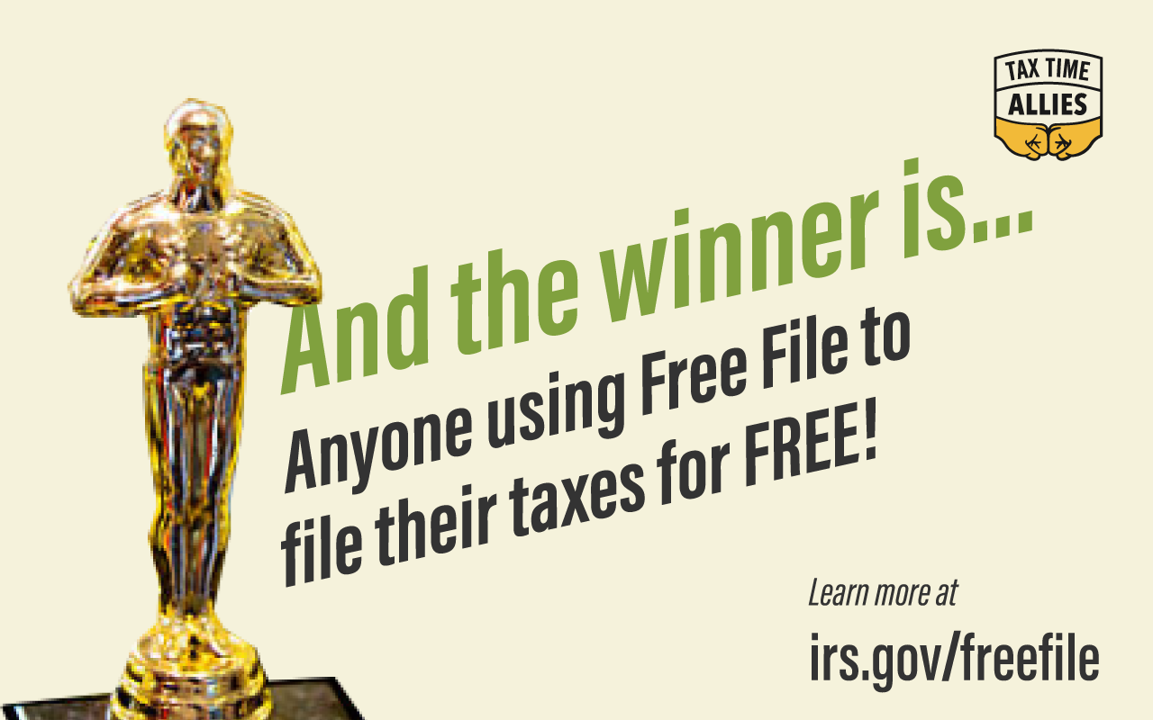 | Facebook:  - Before you start watching the red carpet this Oscar Day, see if you’re eligible to get your taxes filed through Free File. The program allows you to use brand name tax preparation software to prepare your own taxes totally free of charge. And you can use the hundreds of dollars you save to buy your own red carpet look! See more at www.irs.gov/freefile.  Twitter:  - Today’s the #Oscars, and Free File’s performance in helping people prepare their tax returns is winning all the awards. See if you qualify at www.irs.gov/freefile.
2/25-3/2 | 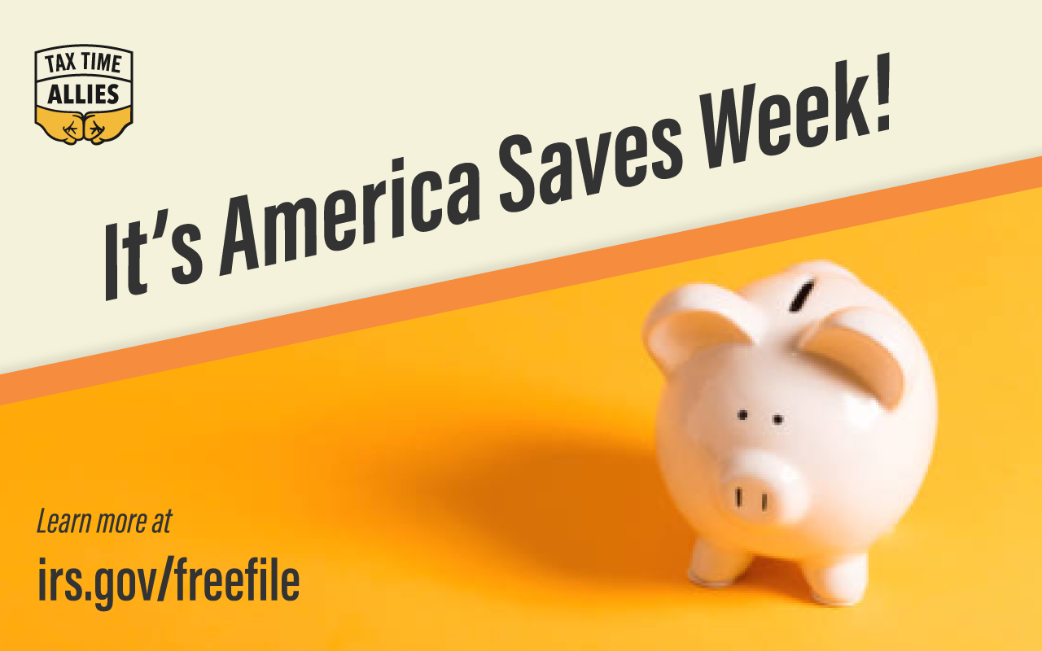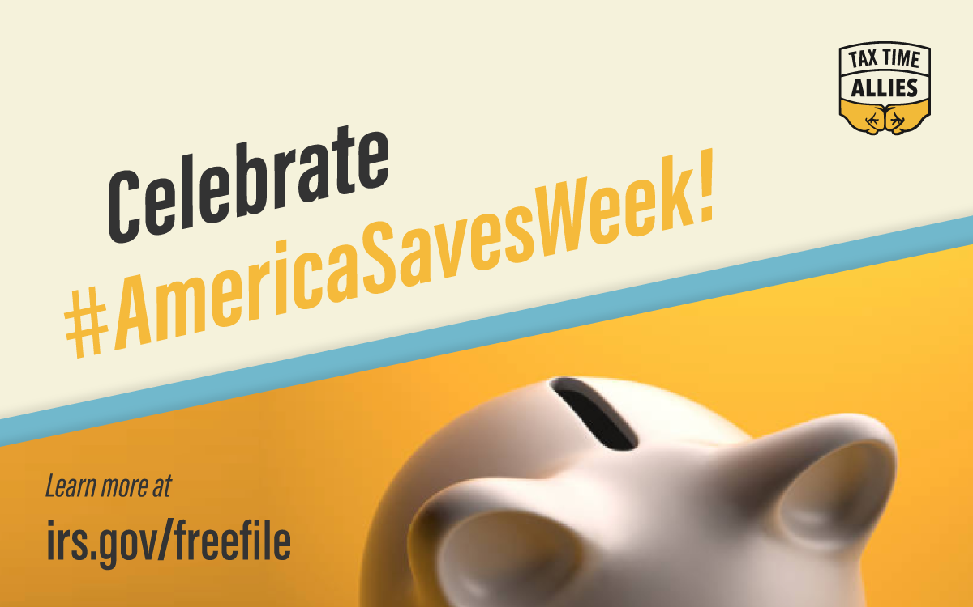 | Facebook:  - No need to fork over any of your hard earned tax return with IRS Free File. Get access to name brand tax software at no cost to you. Learn more at www.irs.gov/freefile.  - This is America Saves Week, which is dedicated to encouraging Americans to save for the future. We know that even a little bit of savings can make all the difference to some families, which is why we’re encouraging you to use IRS Free File or VITA services to file your taxes free of charge and save the difference. Save hundreds on tax prep and make sure you get the entire refund you’re owed. What better way is there to save? See more at www.irs.gov/freefile.  Twitter:  - It’s #AmericaSavesWeek! Use IRS #FreeTaxPrep to prepare your taxes, save more and improve your financial future. Learn more at www.irs.gov/freefile.  - This #AmericaSavesWeek, don’t wait to start improving your financial future. Use IRS #FreeFile to prepare your taxes and save $$ on #TaxPrep now.
3/5 |  | Facebook:  - Today is Mardi Gras, and what better way to celebrate all things excess than to help secure yourself the entire refund you’re owed and save money on tax preparation fees? If you use your refund wisely, you may even save enough for a trip to New Orleans next year! See if you qualify at www.irs.gov/freefile.  Twitter:  - Happy #MardiGras! Take a break from the parades and do your taxes with #FreeFile or at a #VITA site. It’ll be a party!  - Unmask a bigger tax refund with #FreeFile. Find out more at www.irs.gov/freefile.
3/14 | 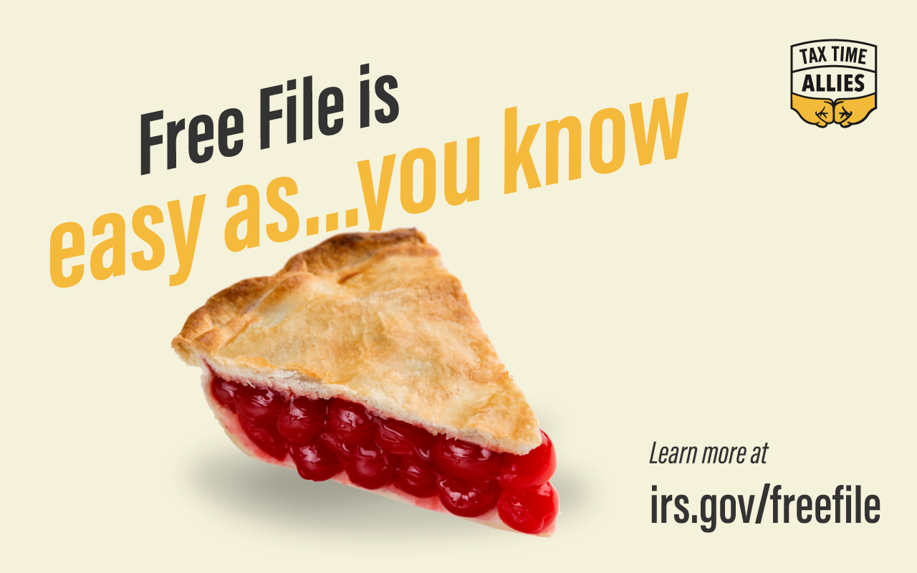 | Facebook:  - With the help of the IRS Free File program, your refund can come full circle. Click the link below to learn more. Happy Pi Day! www.irs.gov/freefile.  Twitter:  - #FreeFile is here to help you save money on tax prep. In fact, Free File is as easy as Pi! #PiDay www.irs.gov/freefile.
TBD (was 3/14) | 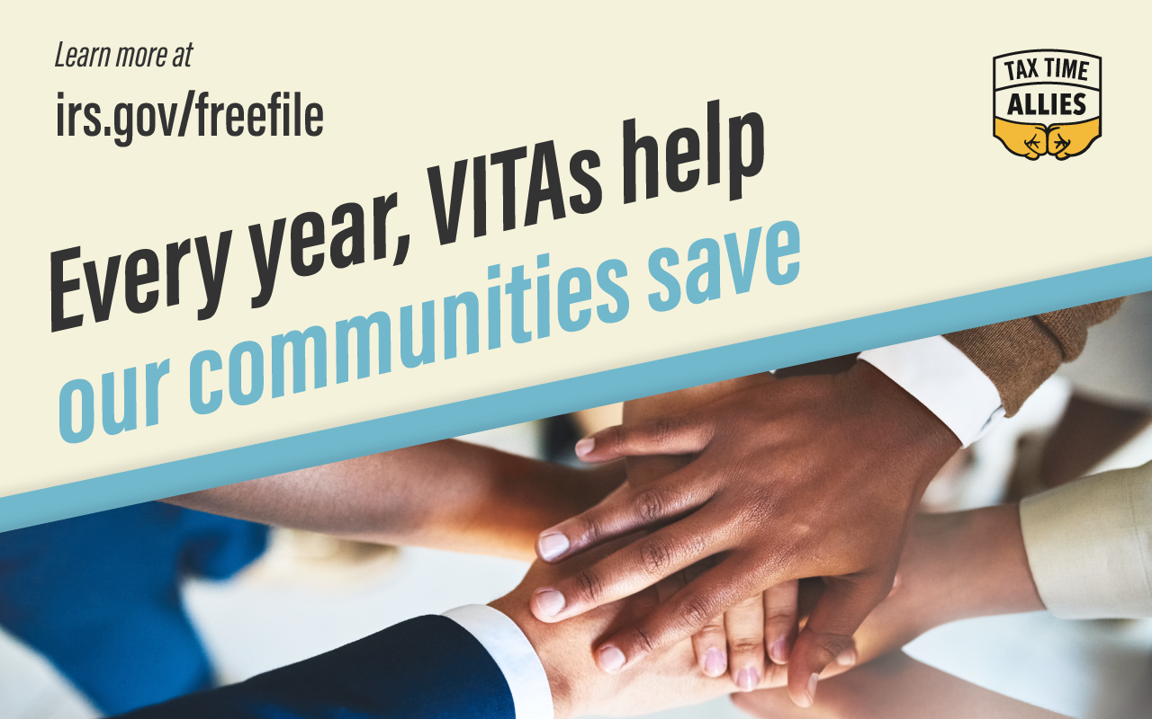 | Facebook:  - We are so grateful to the VITAs in our community that are helping all of us save money on tax preparation fees, get our taxes done right and begin using that refund to improve our financial lives. Take advantage of the Tax Time Moment this VITA Awareness Day by visiting a VITA site. See if you’re eligible at www.irs.gov/vita.  Twitter:  - #VITAs in our community are a trustworthy resource every tax season. Thank you to our VITAs! Learn more at irs.gov/vita.  - Thank you, VITAs for providing IRS-certified free tax prep to our community each year! #VITAAwarenessDay.
3/17 |  | Facebook:  - Not only is today St Patrick’s Day, it’s also one month until tax day! Make your own luck this tax season by using Free File or visiting a VITA site to have your taxes done for free and get the entire refund you’re owed. You’ll be able to use that refund to improve your financial life. Learn more at www.irs.gov/freefile.  Twitter:  - Over 70% of Americans can be extra lucky this #StPatricksDay by using IRS #FreeFile to file taxes. Learn more at www.irs.gov/freefile.
3/19-4/8 | 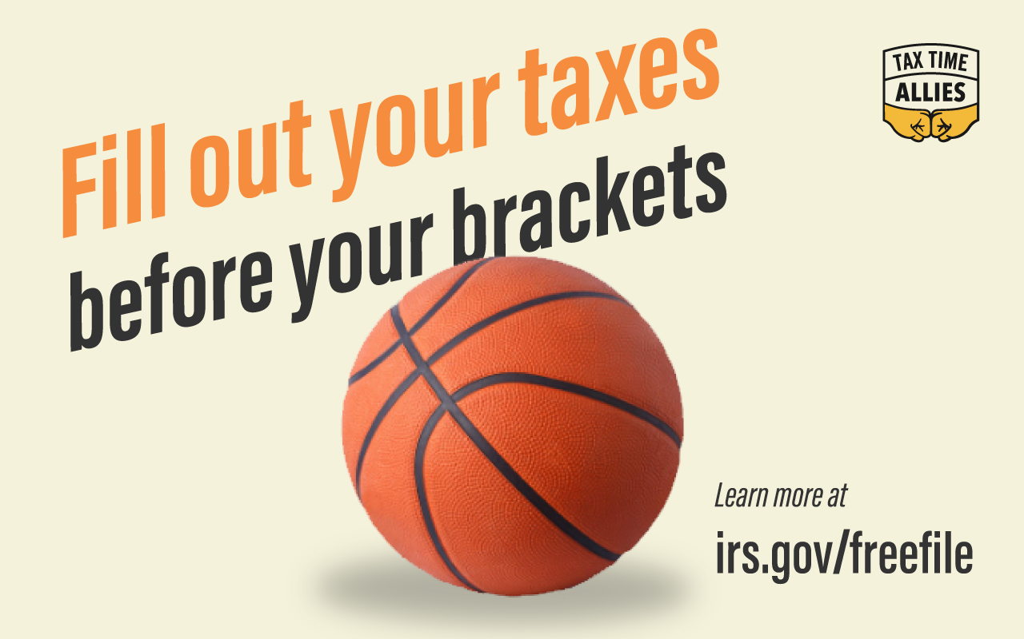 | Facebook:  - Your March Madness bracket may be busted, but you could still be a big winner this tax season. Find out if you’re eligible for free tax preparation services at www.irs.gov/freefile.  Twitter:  - You could be a big winner this tax season. Find out if you’re eligible for free tax preparation services at www.irs.gov/freefile.
3/20 | 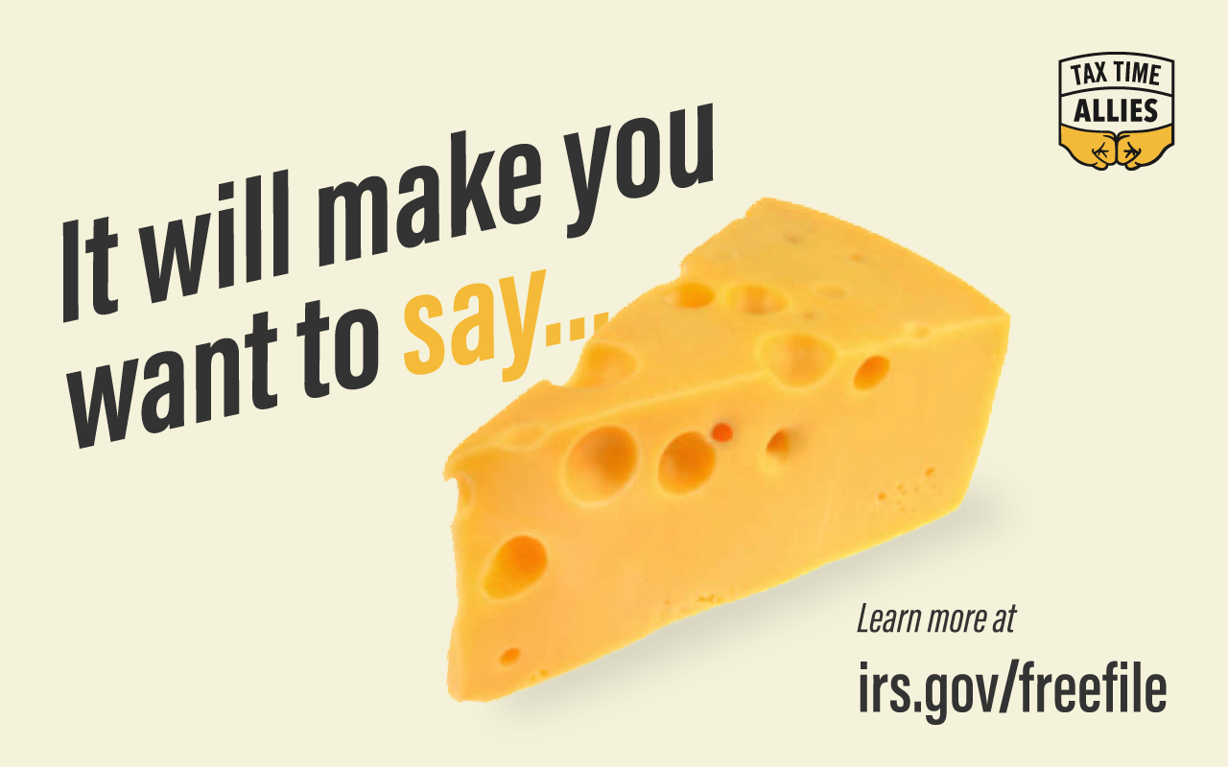 | Facebook:  - Today is the International Day of Happiness, and nothing makes people happier than saving money and getting their taxes done right. IRS-sponsored free tax preparation resources can help save you hundreds in fees to paid preparers. Learn more here: www.irs.gov/freefile.  Twitter:  - It’s #InternationalDayofHappiness, and what could be happier than #FreeTaxPrep? Find out if you qualify at www.irs.gov/freefile.
4/1 | 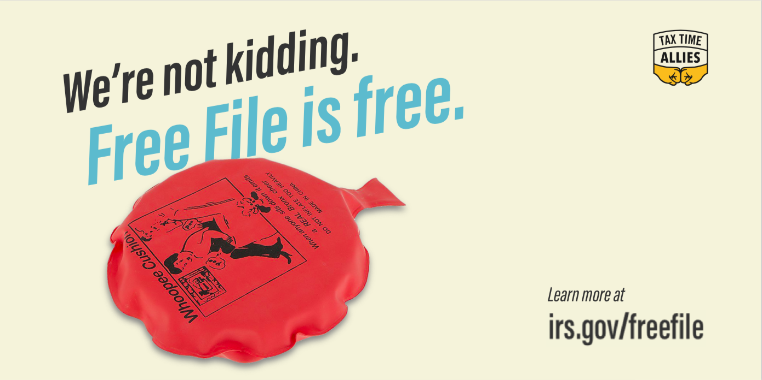 | Facebook:  - No joke, over 70 percent of the country is eligible to use brand name tax preparation software, for FREE, through the IRS Free File program. See if you’re one of them at www.irs.gov/FreeFile.  Twitter:  - Using #FreeFile to prepare your taxes this #AprilFoolsDay can save you hundreds on tax preparation...no joke! See if you’re eligible at www.irs.gov/freefile.
4/8 | 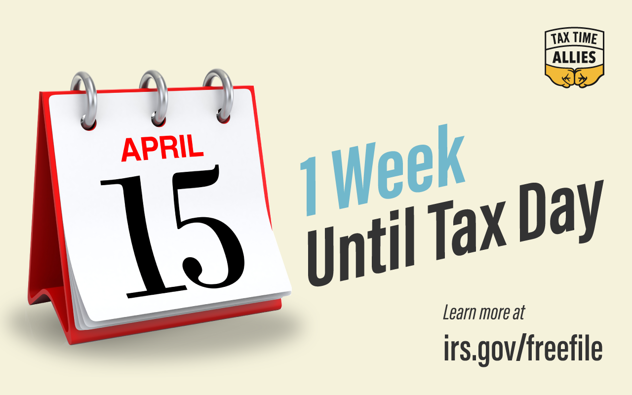 | Facebook:  - One week until tax day! It’s not too late to use IRS-sponsored free tax prep resources to get your taxes done in time and to start your financial year off right. Learn more at www.irs.gov/freefile.  Twitter:  - One week until tax day! It’s not too late to use IRS #FreeTaxPrep to get your taxes done in time and to start your financial year off right. Learn more at www.irs.gov/freefile.
4/11 | 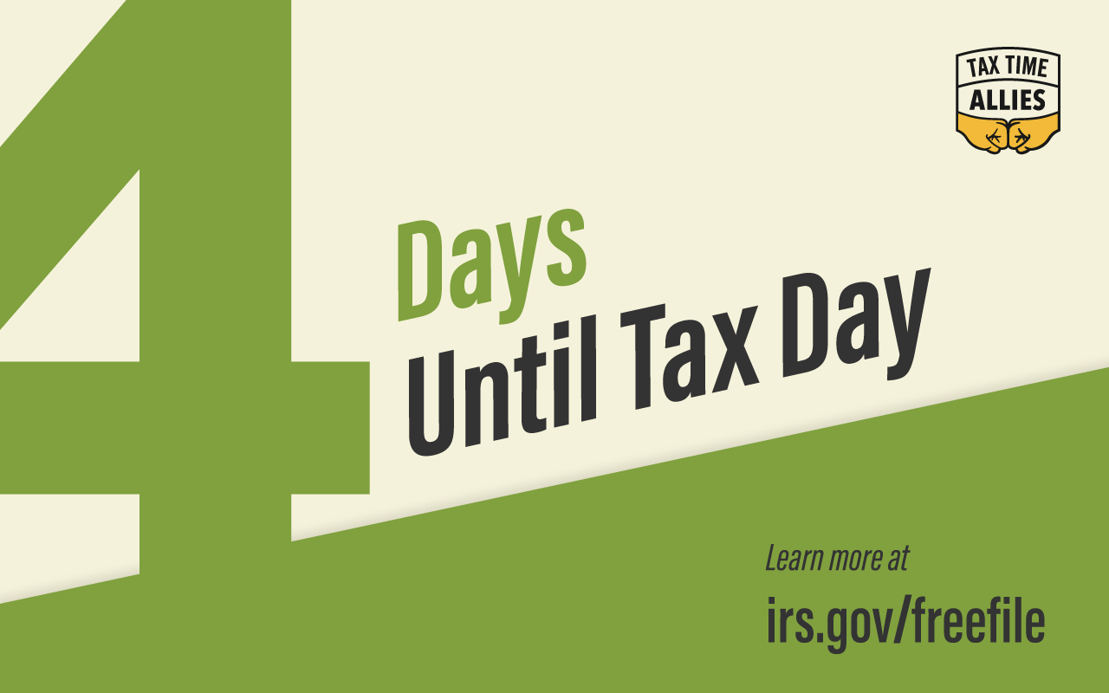 | Facebook:  - Tax day is only 4 days away! Visit www.irs.gov/freefile today and find out if you’re eligible for free tax time savings.  Twitter:  - Tax day is only 4 days away! Visit www.irs.gov/freefile today and find out if you’re eligible for free tax time savings.
4/12 | 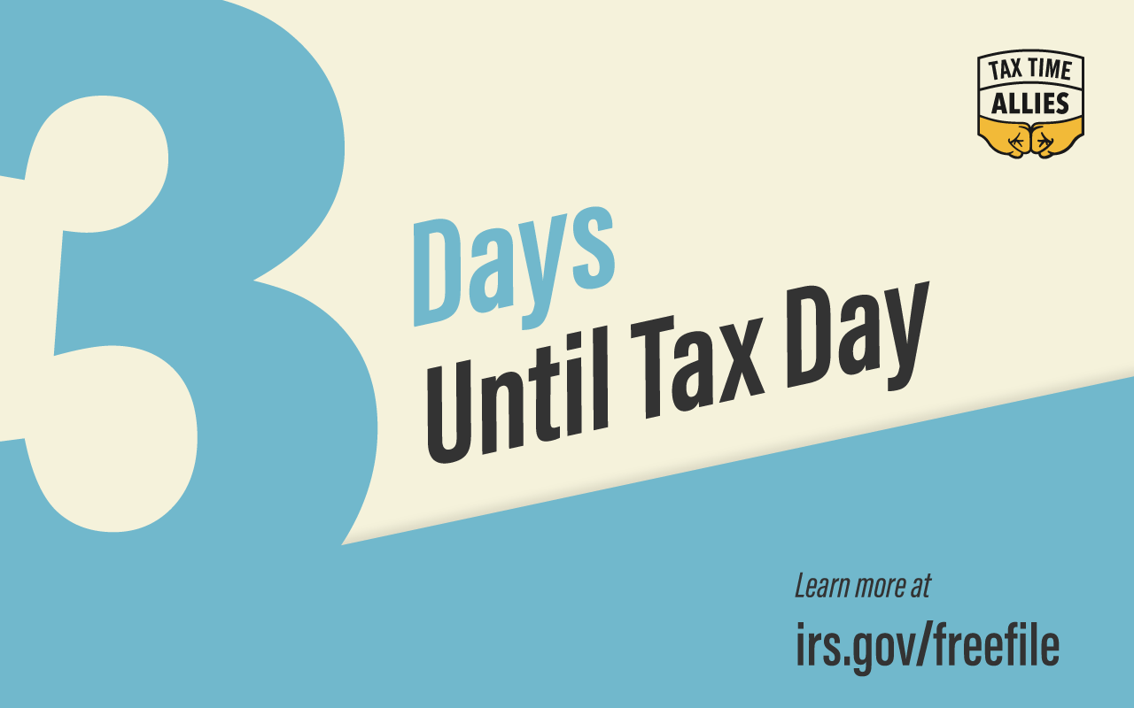 | Facebook:  - Tax day is only 3 days away! Visit www.irs.gov/freefile today and find out if you’re eligible for free tax time savings.  Twitter:  - Tax day is only 3 days away! Visit www.irs.gov/freefile today and find out if you’re eligible for free tax time savings.
4/13 | 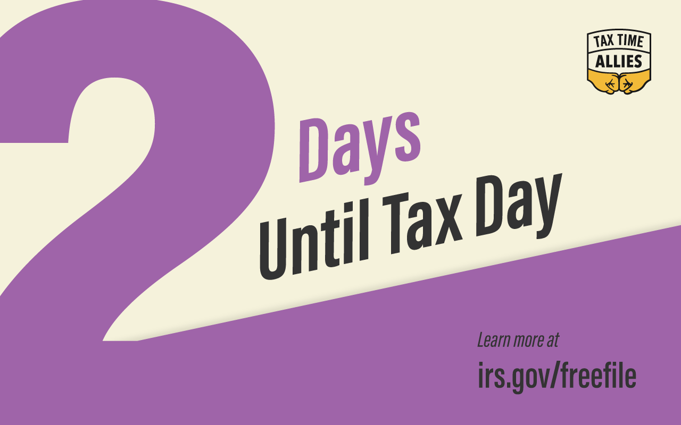 | Facebook:  - 2 days until tax day! Visit www.irs.gov/freefile and find out if you’re eligible to file your taxes online using IRS Free File.  Twitter:  - 2 days until Tax Day! Visit www.irs.gov/freefile and find out if you’re eligible to file your taxes online using IRS #FreeFile.
4/14 | 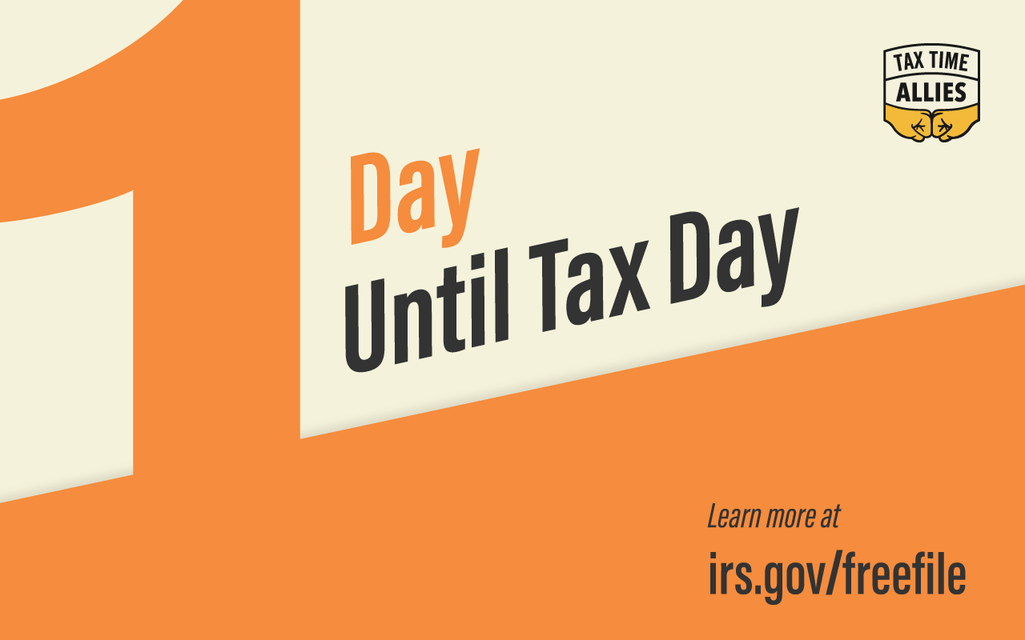 | Facebook:  - Only 1 day until tax day. This is your last chance to use IRS Free File. Get access to name brand tax software at no cost! See if you’re eligible at www.irs.gov/freefile.  - Today is your last chance to file your taxes using IRS Free File. See if you’re eligible at www.irs.gov/freefile.  Twitter:  - Only 1 day until tax day. This is your last chance to use IRS #FreeFile. Get access to name brand tax software at no cost! See if you’re eligible at www.irs.gov/freefile.  - Today is your last chance to file your taxes using IRS #FreeFile. See if you’re eligible at www.irs.gov/freefile.
4/15 | 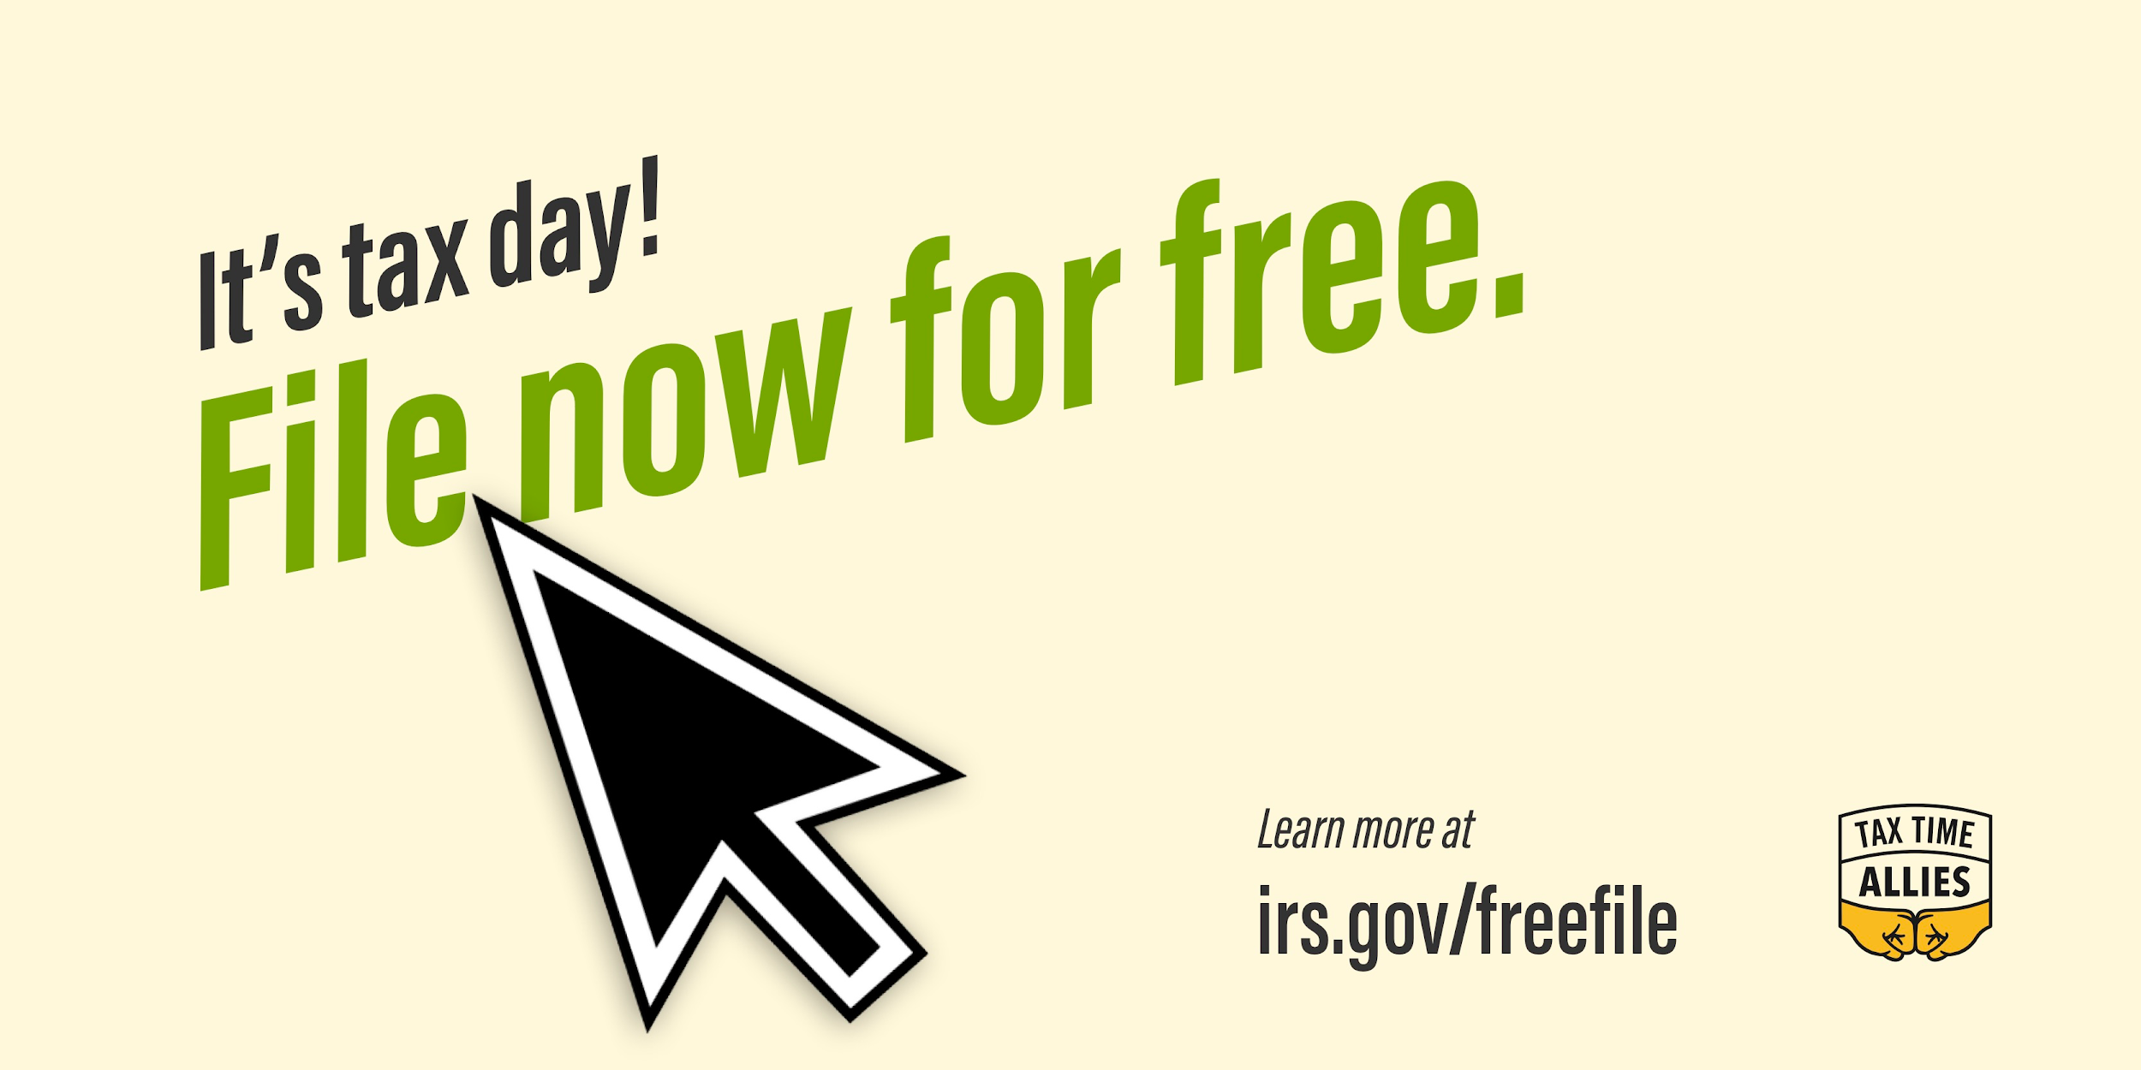 | Facebook:  - Today is tax day, which means that it’s the last day to use IRS-sponsored free tax preparation resources, like IRS Free File, VITA and TCE, to get your taxes done right and submitted on time. But that doesn’t mean that this is the end of the journey. The tax refund you secure through Free File will give you the opportunity to better your financial life and begin preparing for a more secure financial future. Enjoy your Tax Time Moment, and we’ll see you next year!  Twitter:  - It’s #TaxDay! The refund that’s coming could mean the difference in your financial life. Use it well!  - Today may be #TaxDay, but you can start preparing for next tax season right now! Use your refund to better your financial life.

